**CREATING AN ACCOUNT, APPLYING FOR A PERMIT AND RENEWING A PERMIT**

# Creating an account

If you are a new user, you will have to create a new account.

In your browser, search for East Herts Council and then search for Resident Parking Permits.

Click on the link “set up an online account”.

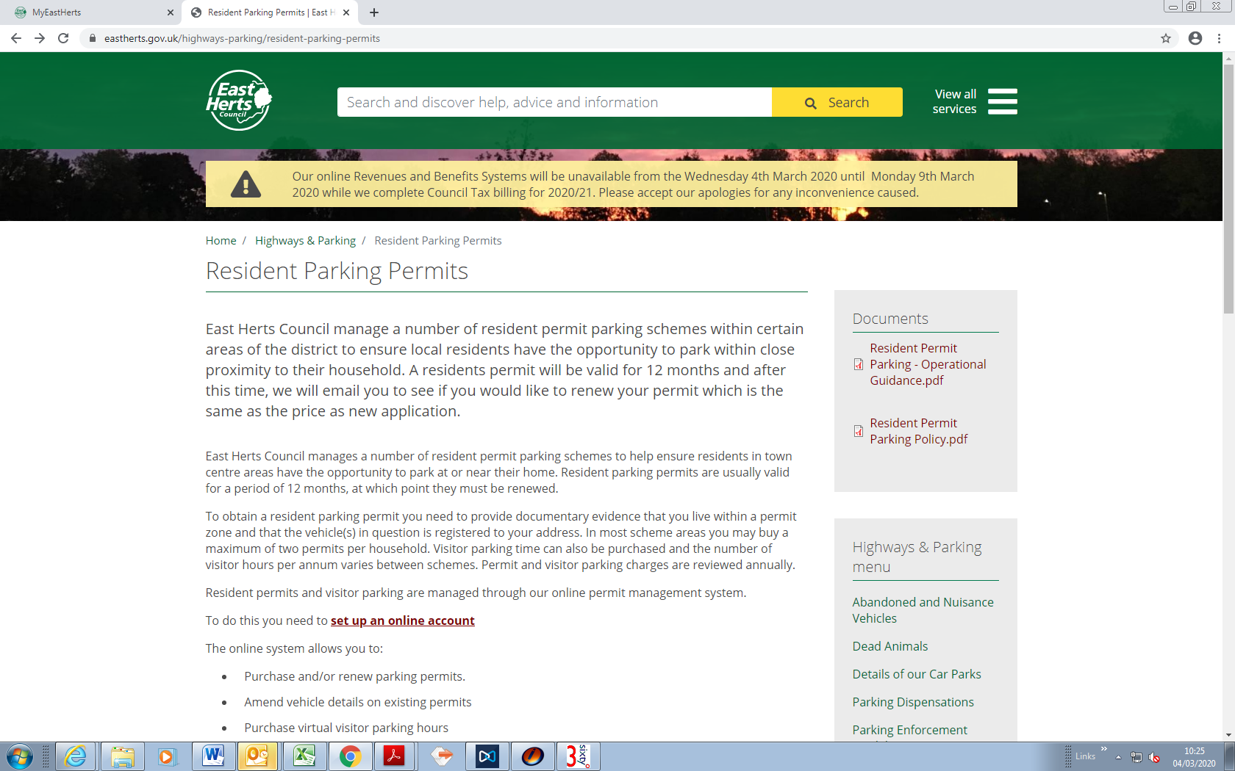

On the next screen select “Create a new account”.

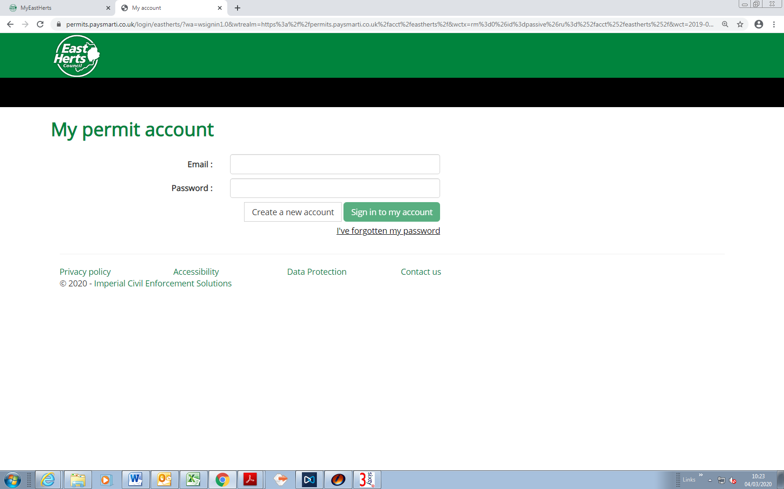

You will then be directed to “My permit account registration – step one”.

Enter all of your details and then click “Next”.

The password must be at least 8 characters and include at least one number, one uppercase and one lowercase letter. You will need to remember this password.

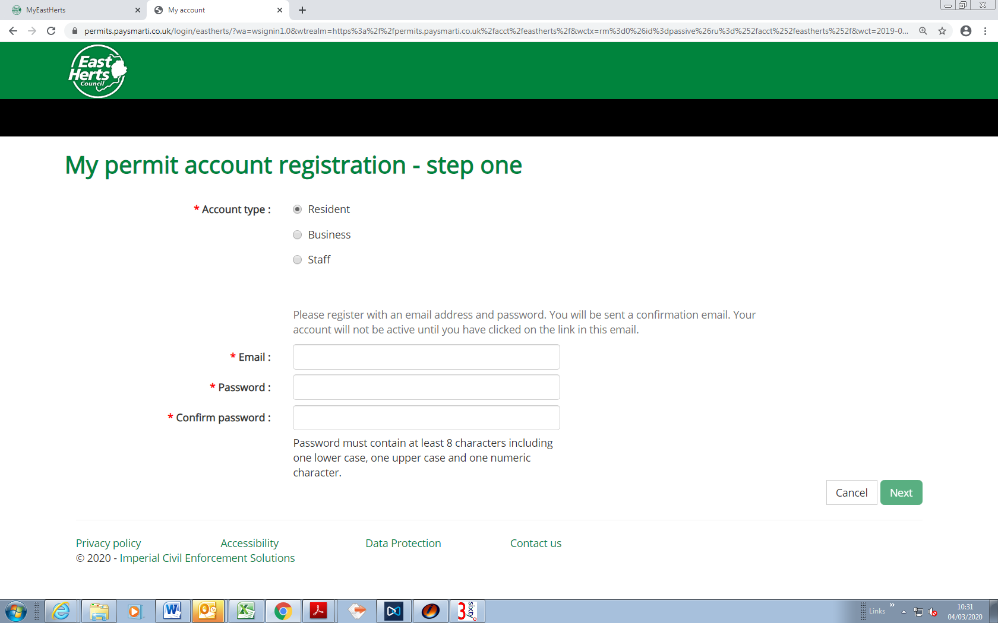

On the next screen (step two), fill in your details, in the “Search postcode” box, enter your postcode and click “Find”

You will then see a dropdown list of addresses for your postcode, select your house number and click “Finish”

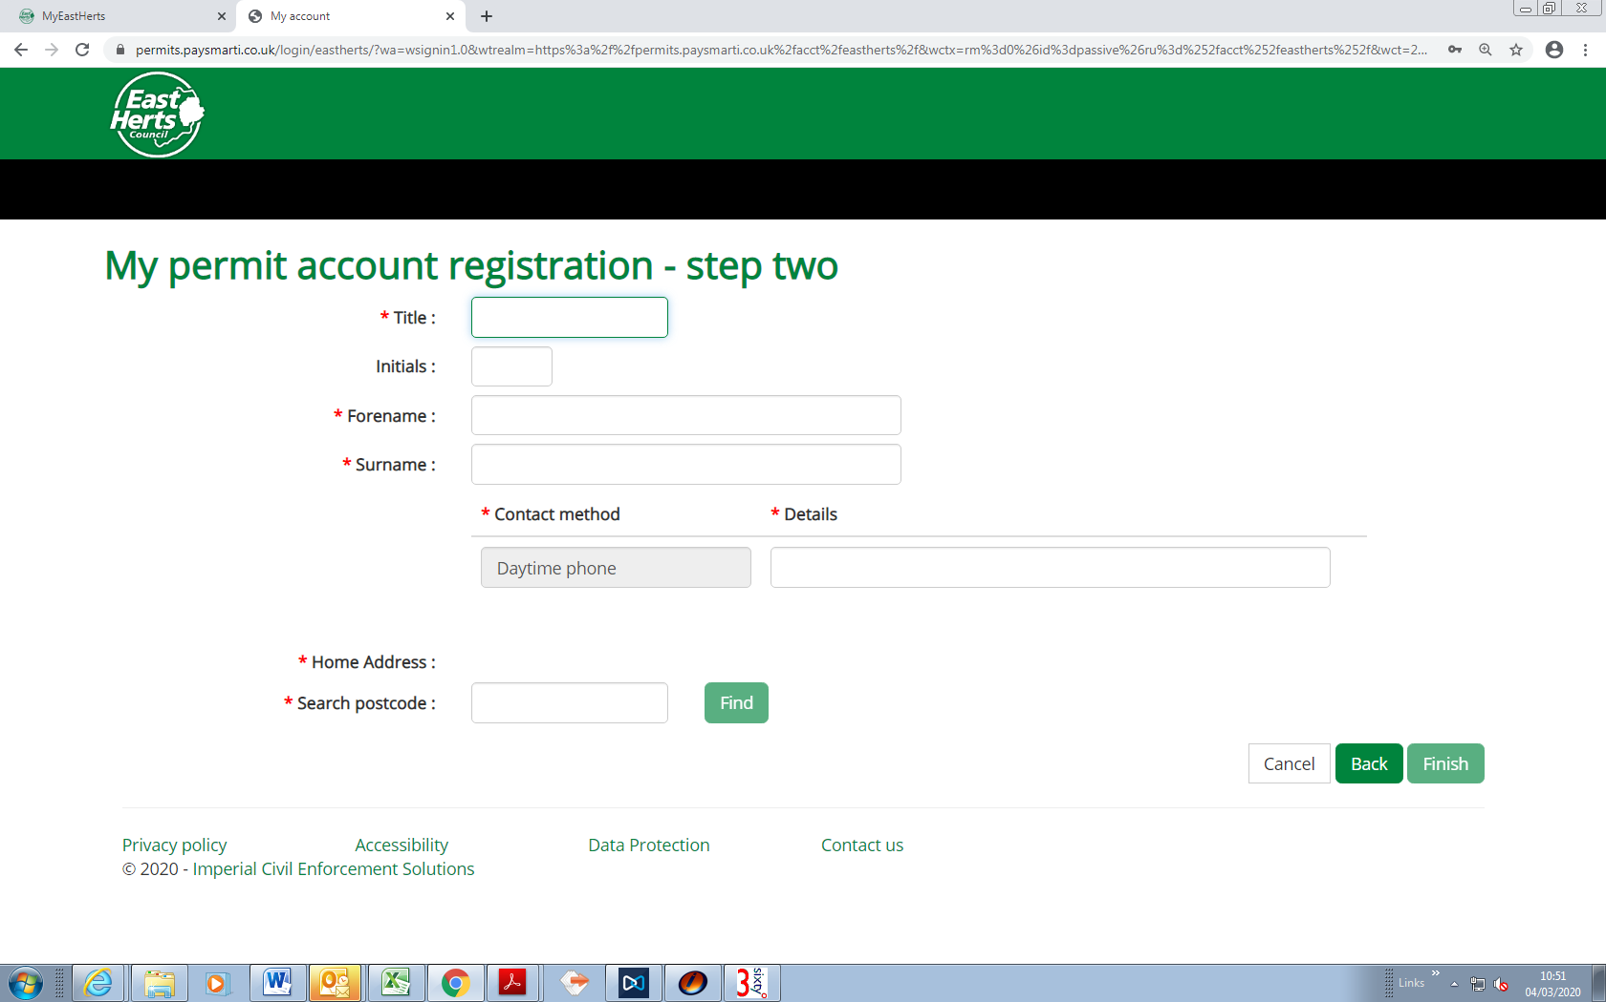

You can then click on “Return to login”.

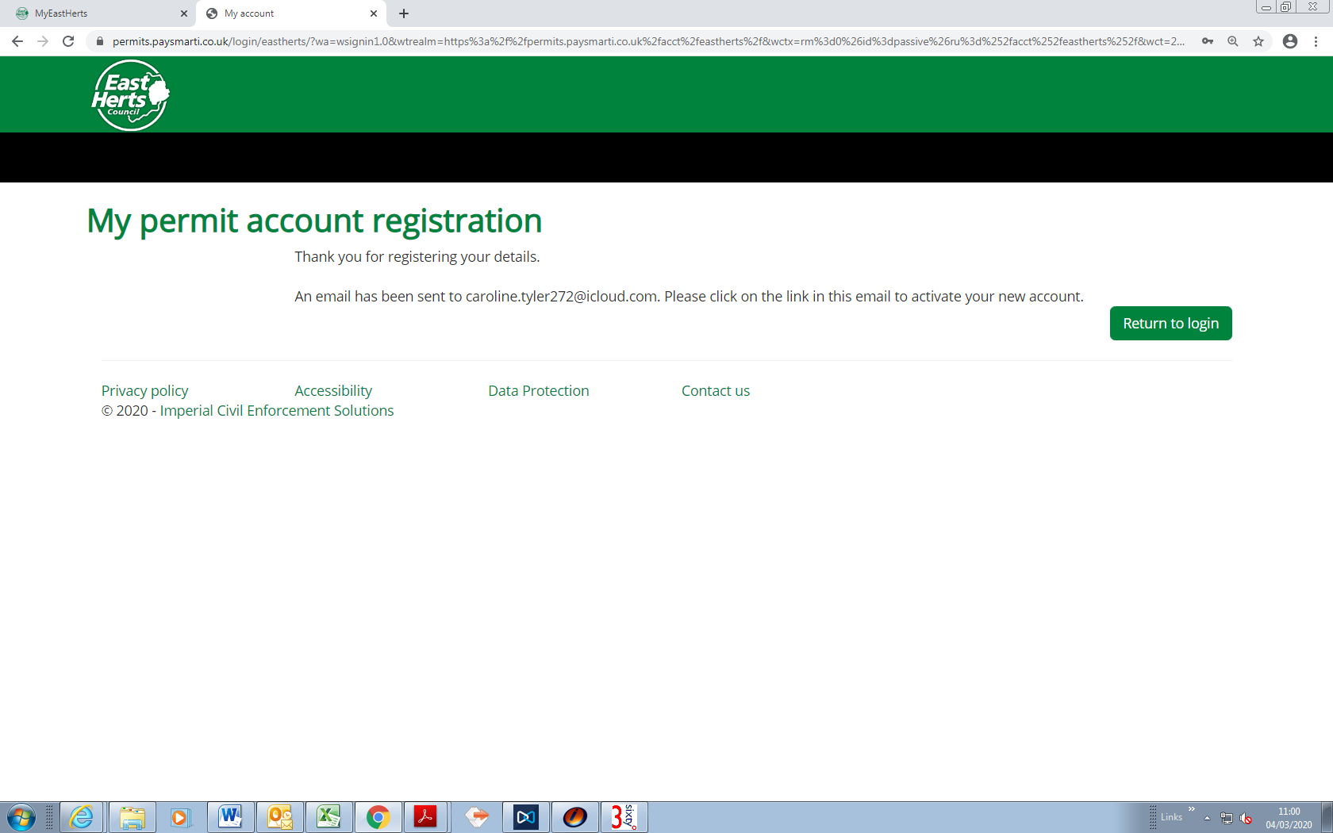

*Please note, if your address is not included in a residential permit area, you will be unable to continue creating an account and will receive an error message.

You will receive an automated email asking you to “confirm your account registration”. Please click on that link. ***Please note that your account will not be active until you have clicked on this link and activated your account***.

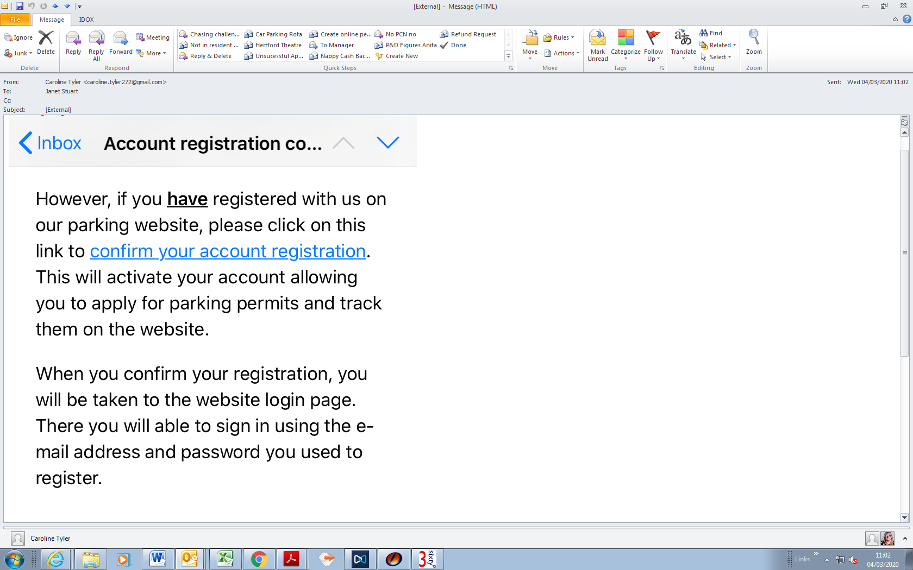

***Note: If you don’t see an email, please check your spam or junk mail as it may be in one of those folders.***

Once you have clicked on the link, you will be directed to the following page, please log into your account using your email address you registered with and the password you created and select “Sign in to my account”.

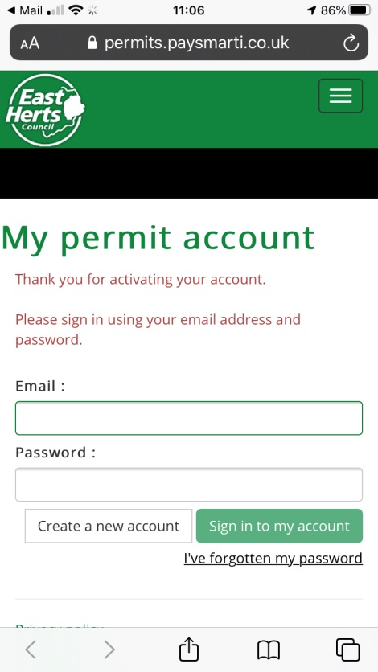

You will then be directed to the home page of your online account.

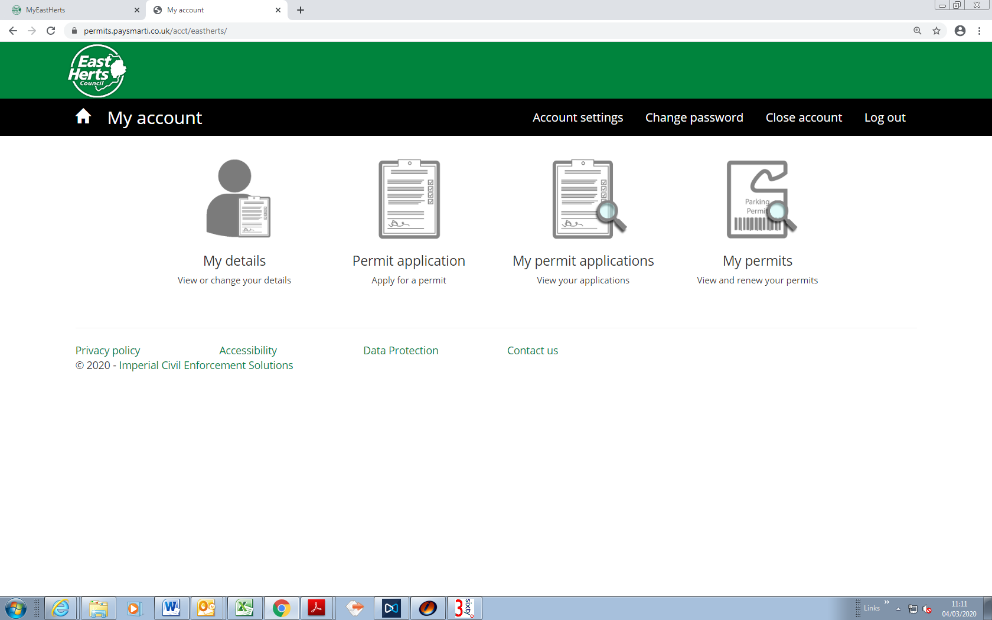

Once you have logged into your account you will be able to:

(a) Manage your details

(b) Apply for a permit

(c) See current permit applications which you have submitted

(d) View your current permits and vouchers and renew your permit

## My details (View or change your details)

You can change your address (please note, you can only change your address to another eligible address. changing the address may also affect permit and or vouchers you have previously purchased), telephone number and name.

## Permit application (Apply for a permit)

The information you have provided when setting up your account will determine what permit categories you are entitled to.

***Please note: If you are trying to apply for a resident permit and the permit category in the dropdown list does not show “Resident”, your property is not an eligible address for a permit. Please see screen shot below which shows when an address is not eligible.***

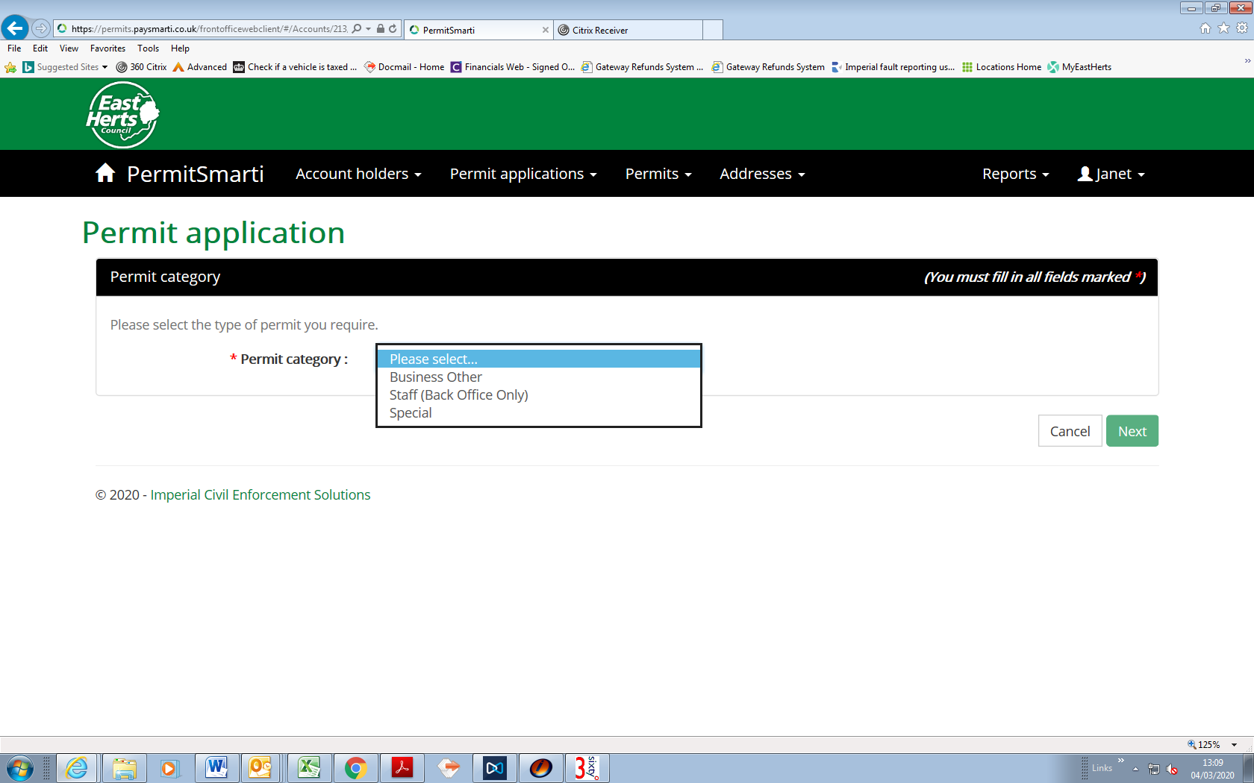

The address on this ‘TEST’ account is for permit zone W2 which offers permits for businesses (a) vouchers (b) if the resident is in receipt of a state pension they can purchase state pension vouchers which give double the allocation at half the price (evidence of receipt of state pension will be required) (c) Business other this is if a resident is in need of carer services from a care company (d) or Residents permits (e).

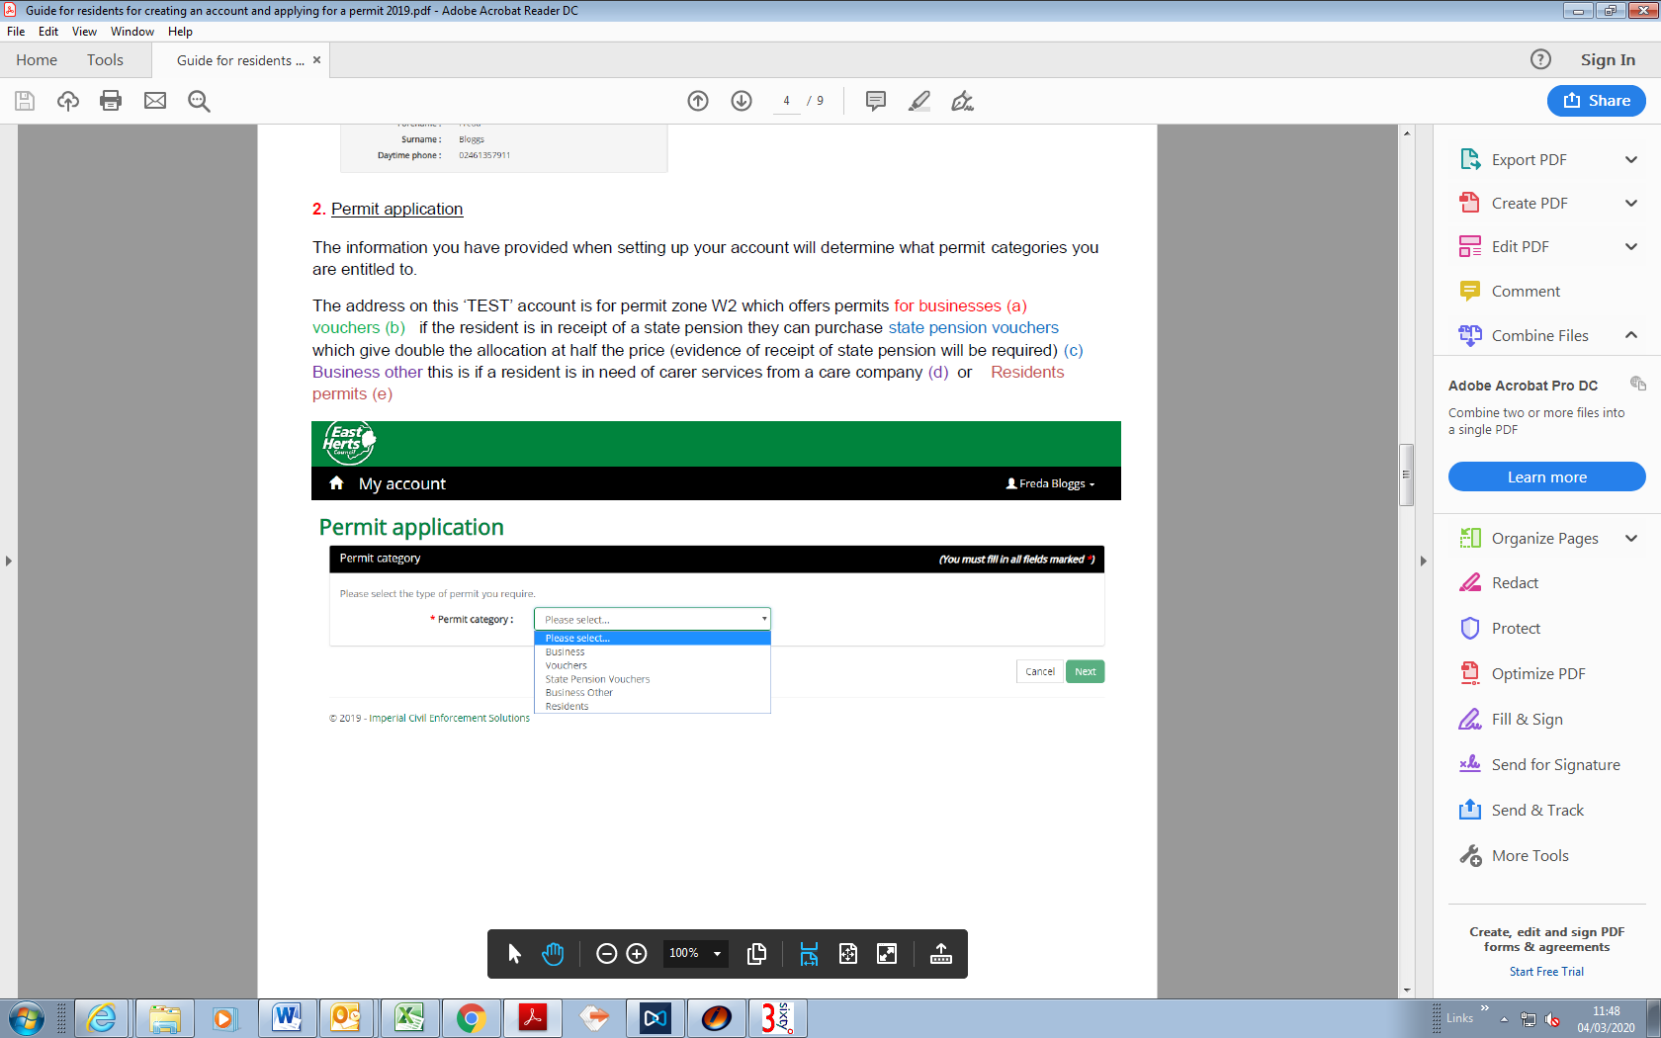

Residents permit chosen. The system will confirm the eligible address. Then press “Next”.

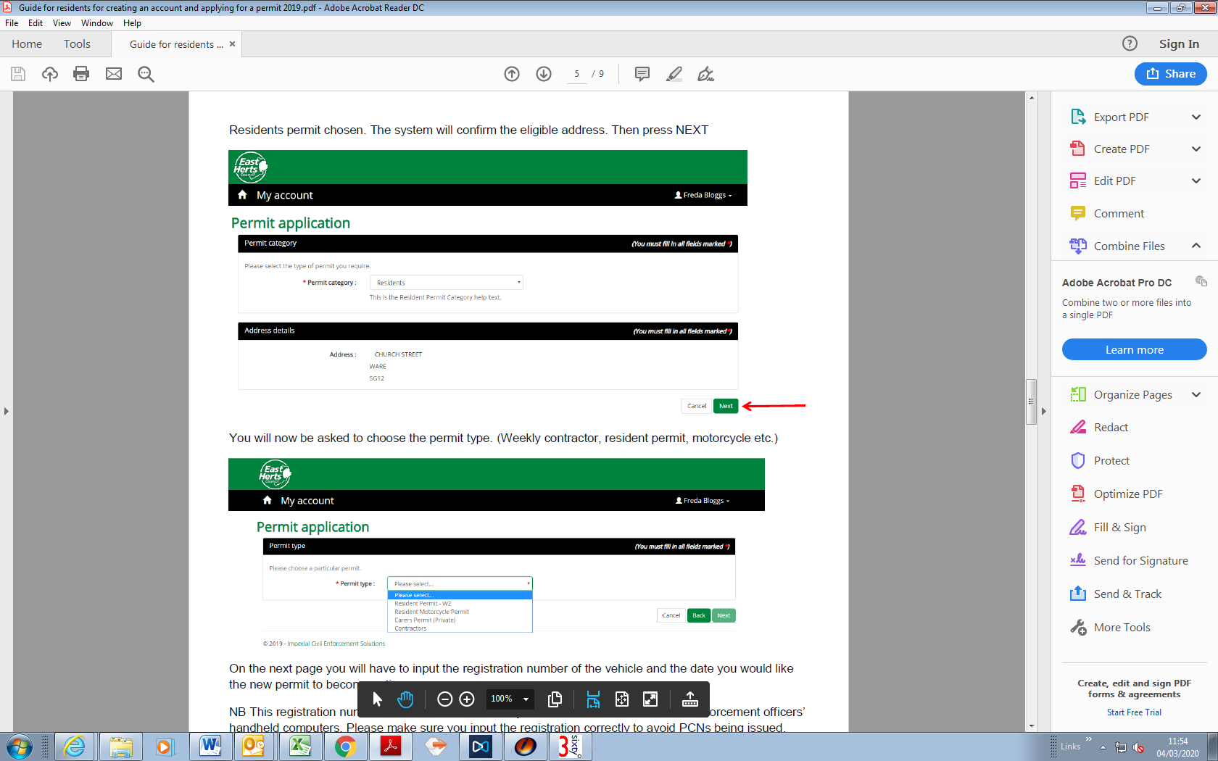

You will now be asked to choose the permit type. (Weekly contractor, resident permit, motorcycle etc.) once selected, click “Next”

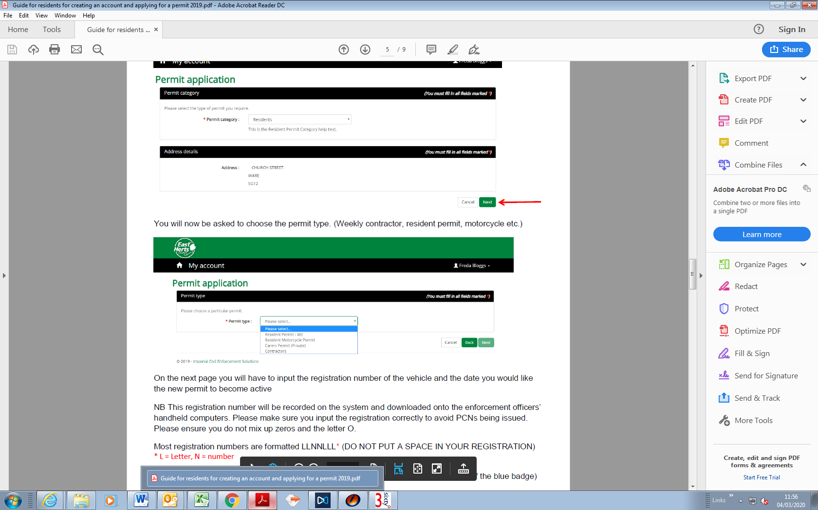

On the next page you will have to input the registration number of the vehicle and the date you would like the new permit to become active.

NB: This registration number will be recorded on the system and downloaded onto the enforcement officers’ handheld computers. Please make sure you input the registration correctly to avoid PCNs being issued. Please ensure you do not mix up zeros and the letter O.

Most registration numbers are formatted LLNNLLL* (DO NOT PUT A SPACE IN YOUR REGISTRATION)

* L = Letter, N = number

You will be asked if you are a blue badge holder (If yes, you will need to provide a copy of the blue badge)

Resident permits will only be issued to vehicles that are smaller than 5.25m long and 2.3m high (the size of a transit van). If you answer yes to this question and we subsequently find that your vehicle is larger, your permit will automatically be cancelled.

Once all the information has been input, press click “Next”.

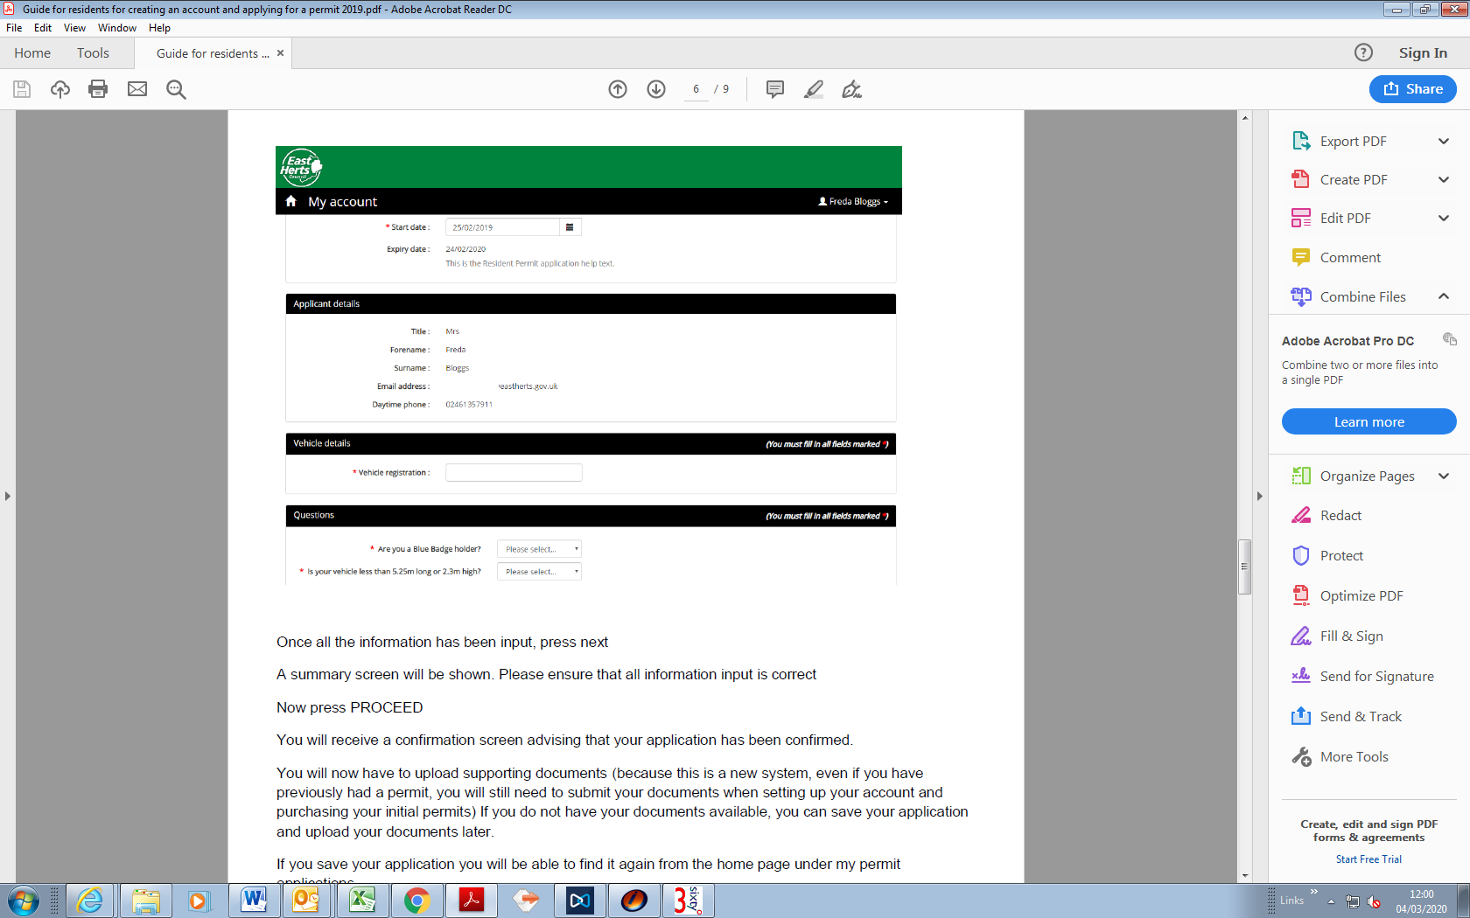

A summary screen will be shown. Please ensure that all information input is correct.

Now press PROCEED.

You will receive a confirmation screen advising that your application has been confirmed.

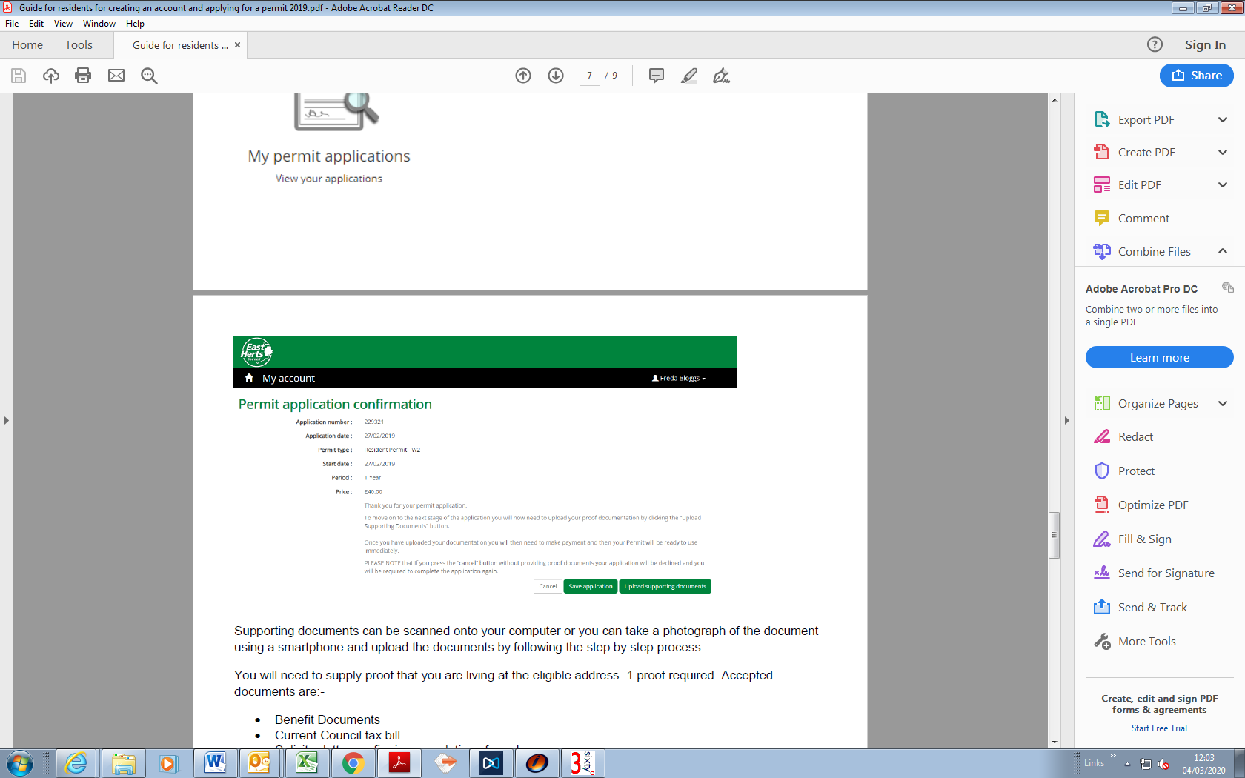

You will now have to upload supporting documents (because this is a new system, even if you have previously had a permit, you will still need to submit your documents when setting up your account and purchasing your initial permits) If you do not have your documents available, you can save your application and upload your documents later.

If you save your application you will be able to find it again from the home page under my permit applications.

Supporting documents can be scanned onto your computer or you can take a photograph of the document using a smartphone and upload the documents by following the step by step process.

You will need to supply proof that you are living at the eligible address. 1 proof required. Accepted documents are:

* Benefit Documents
* Council tax bill (for the current year)
* Solicitor letter confirming completion of purchase (for the current year)
* Tenancy agreement or mortgage statement (for the current year)
* Utility bill dated within the last 3 months

You will also need to provide proof that the vehicle is registered to the eligible address 1 proof required and supply:

* Vehicle registration document – showing the vehicle is registered to the eligible address (V5C/log book)
* Official bill of sale/invoice (for the current year) – showing the eligible address
* Insurance document (for the current year) – showing the eligible address
* Hire/Lease agreement (for the current year) – showing the eligible address

Please note: Road Tax reminders, Car Insurance reminders or Drivers Licences are not accepted as valid proof documents.

If the vehicle is a company car, you will need to supply proof in the form of a company headed letter signed by the company secretary stating you are authorised to drive the car and that the car will be kept at the eligible address.

If you advised that you were a blue badge holder, you will also need to upload a copy of the front and back of this.

When pressing the button, you will be asked to choose what document type you are uploading.

Each document should be loaded and named separately.

For example, if you wish to upload a V5C Log Book as proof of vehicle:

Choose V5C in document type drop down.

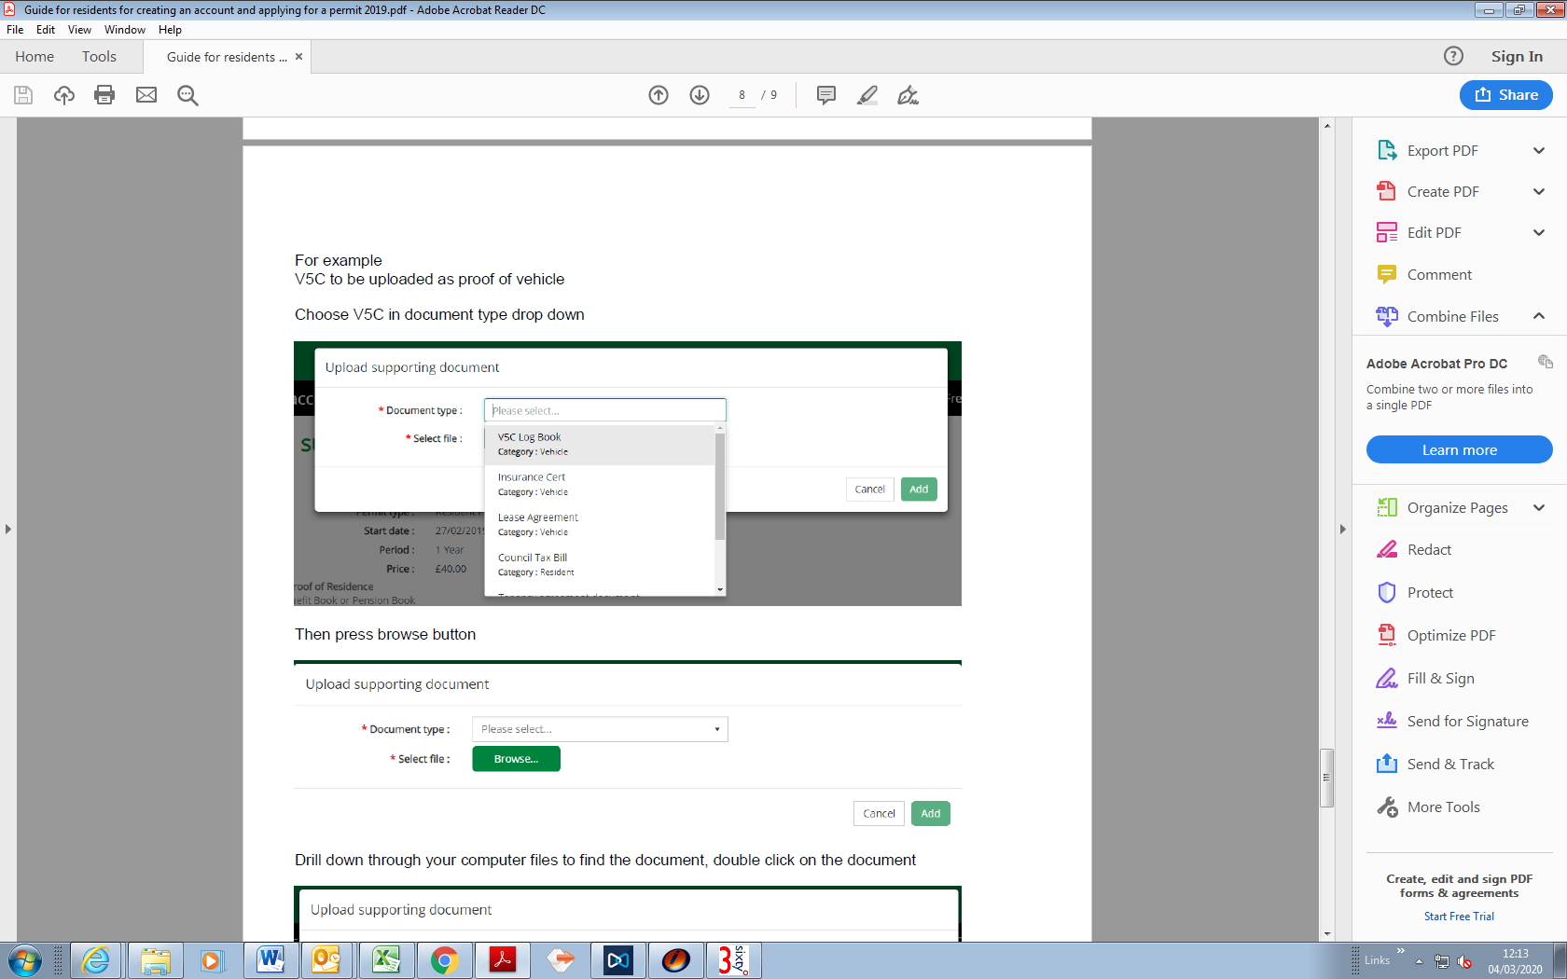

Then press browse button.

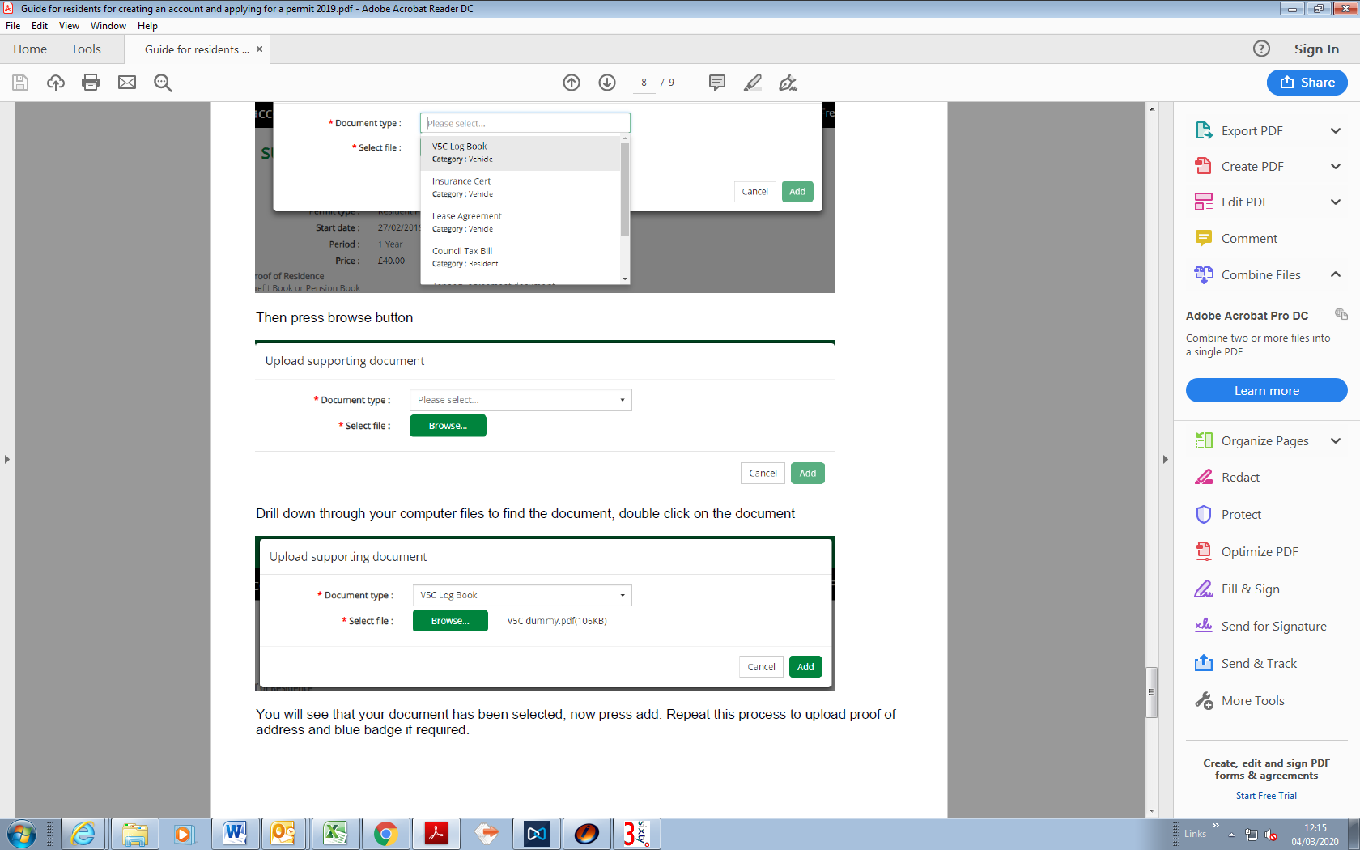

Drill down through your computer files to find the document, double click on the document then click “Add”.

Repeat this process to upload proof of address and blue badge if required.

Once all required documents have been uploaded, you will see these at the bottom of the screen then press “Upload documents”.

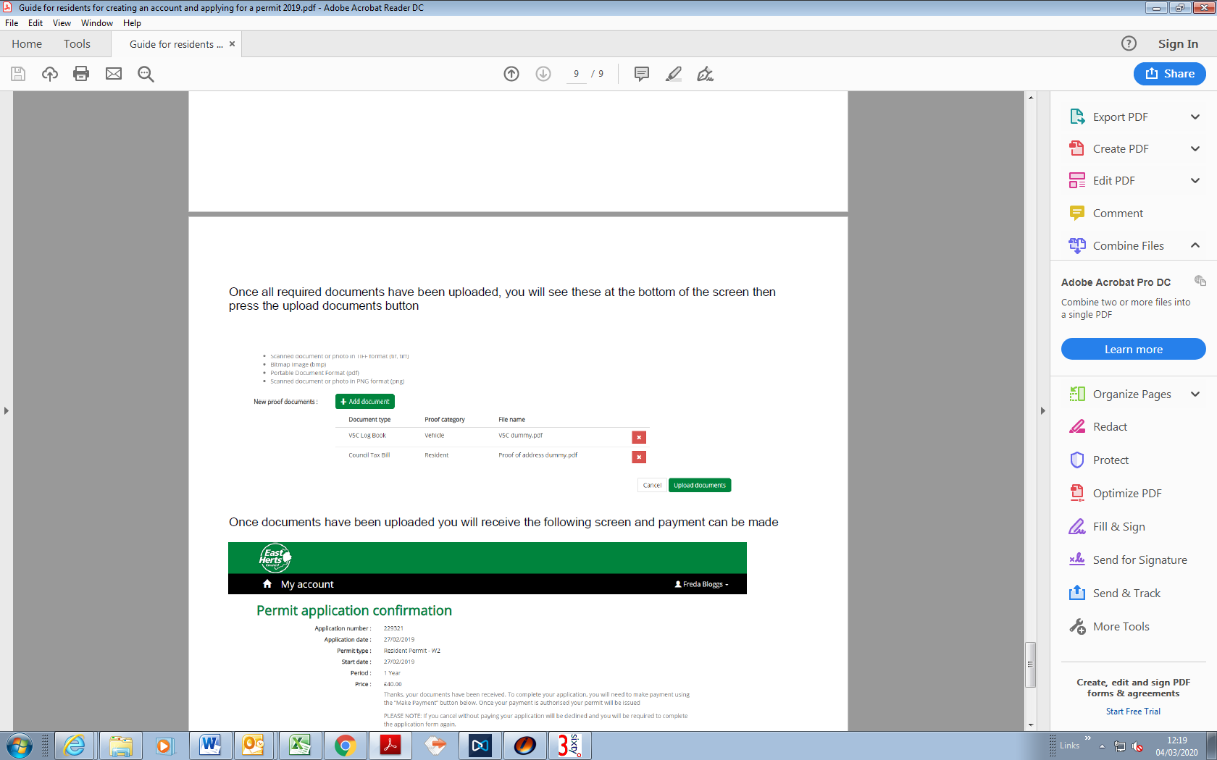

Once documents have been uploaded you will receive the following screen and payment can be made. Click on “Make Payment” and you will be directed to an automated payment system.

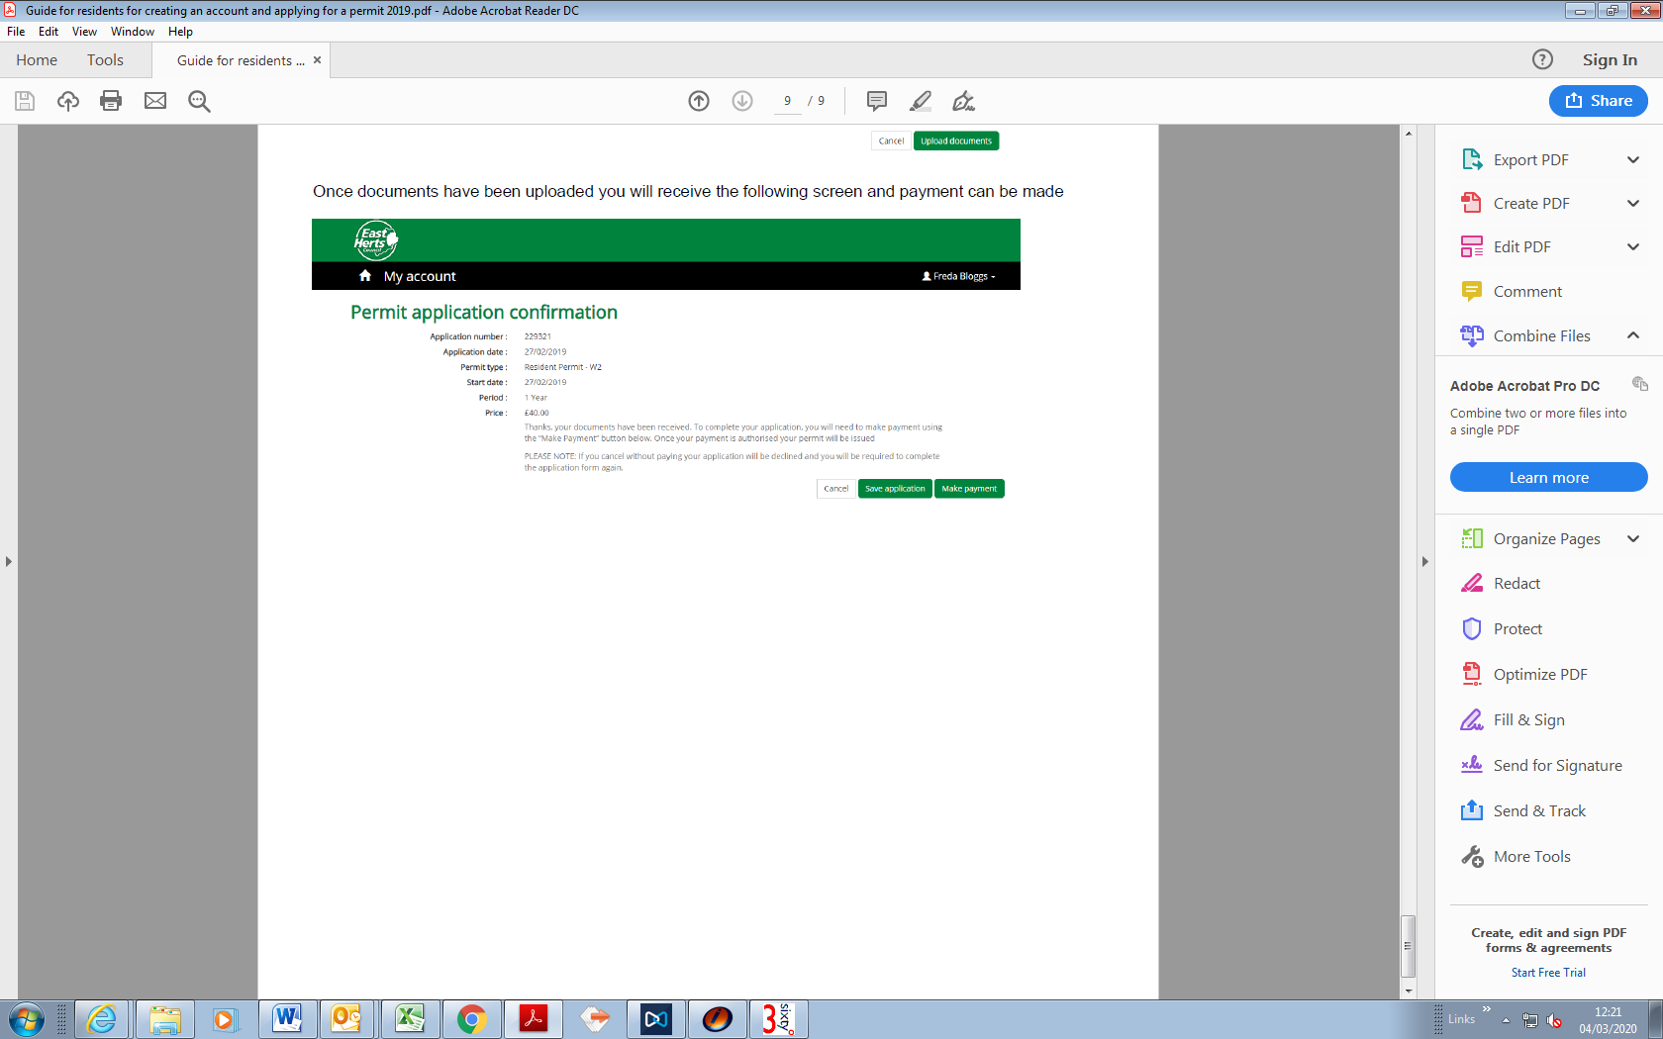

Once you have made payment, you will receive an automated email confirming your permit has been issued showing details of your permit.

## My permit applications (View your applications)

Log into your account and select “My permit applications”. A list of your applications will show and you can view each application. To get back to the previous page, click “Back”.

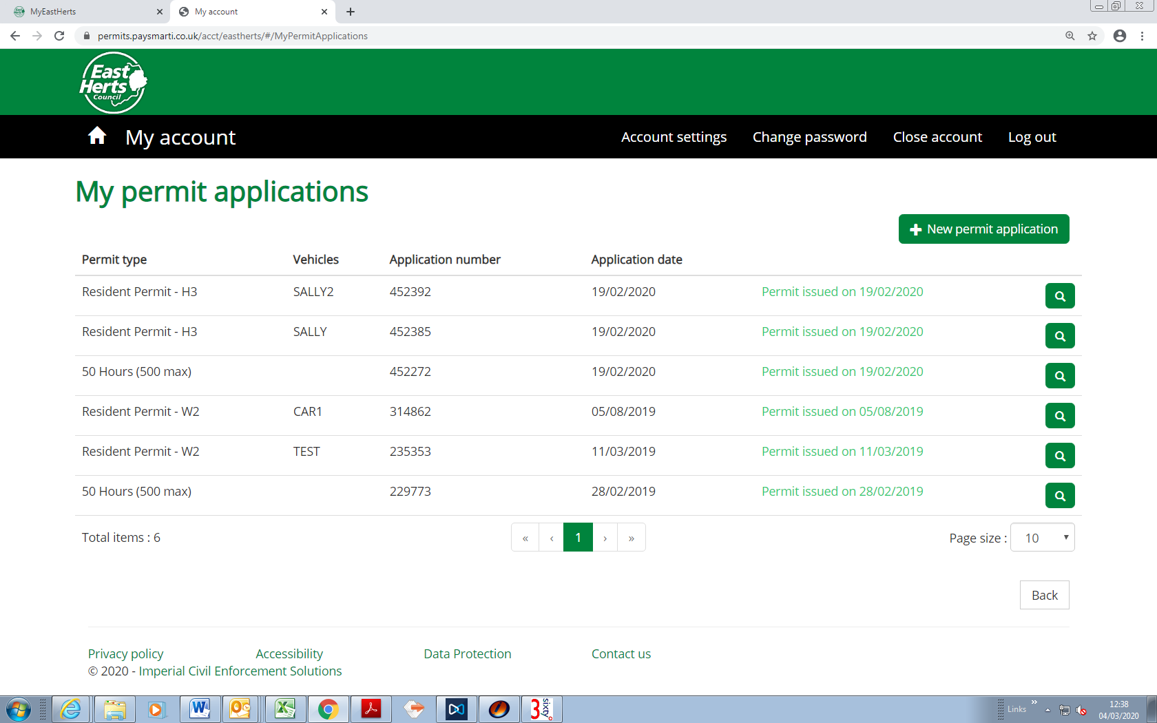

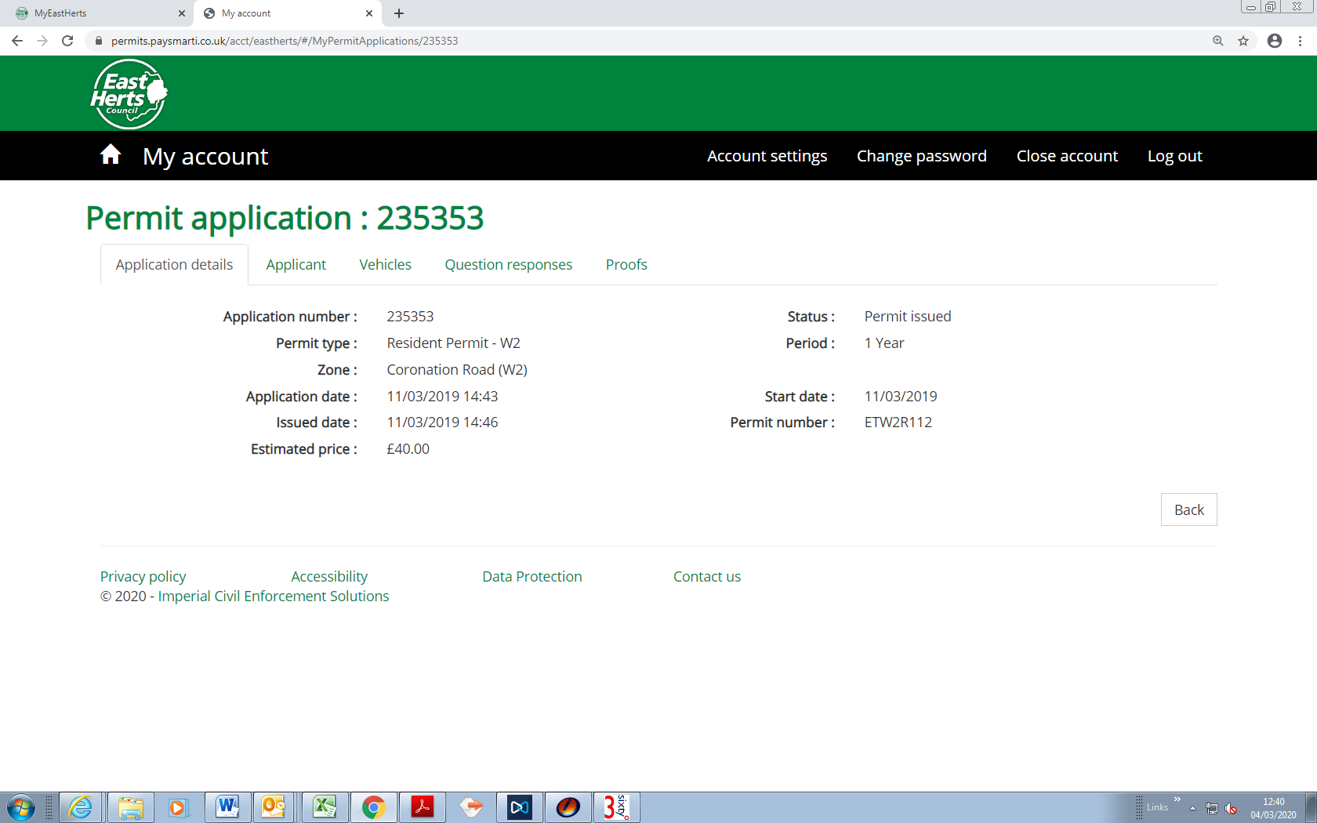

## My permits (View and renew your permits)

Here you can check the status of your permits which shows your permit expiry date.

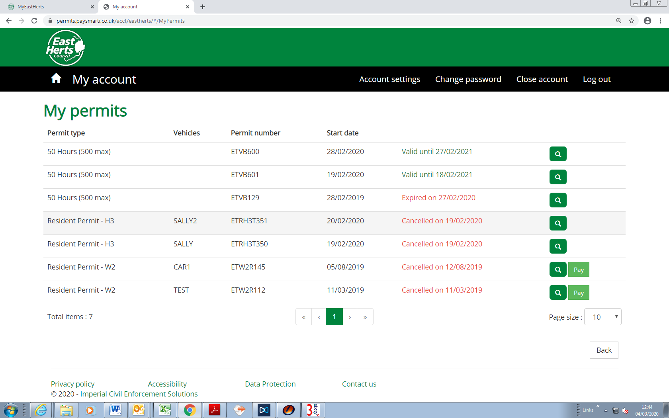

To renew your permit, select the permit to be renewed by clicking on the “Renew” button:

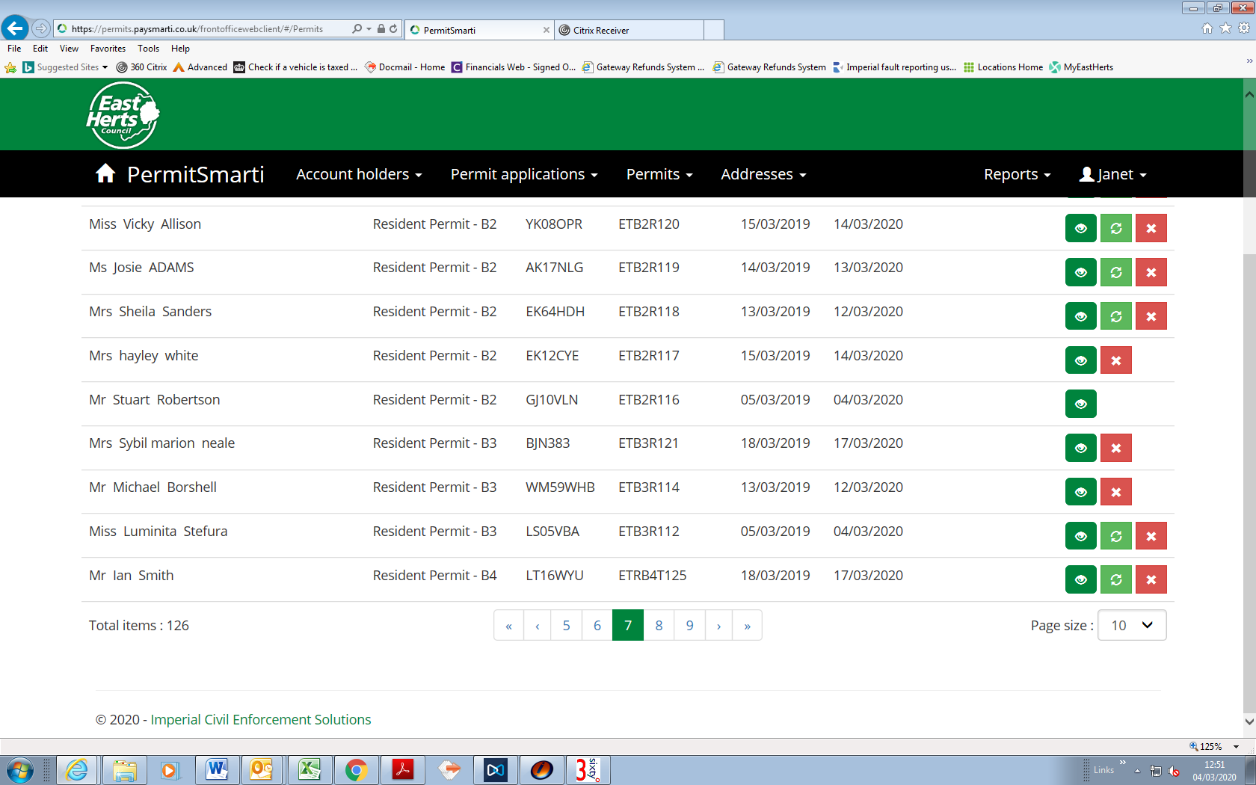

Once you click “Renew” follow the instructions to renew your permit.

***Please note: you cannot renew your permit if your permit has already expired, you will need to create a new application for a permit.***